Freeform Curved Shapes
# Source: AI Source: Provided by: [Data Path: Persons Table -> ID Column: 1, Name_En Column: Motasem Essam] -> From: [ChatGPT] on [7/25/2026]
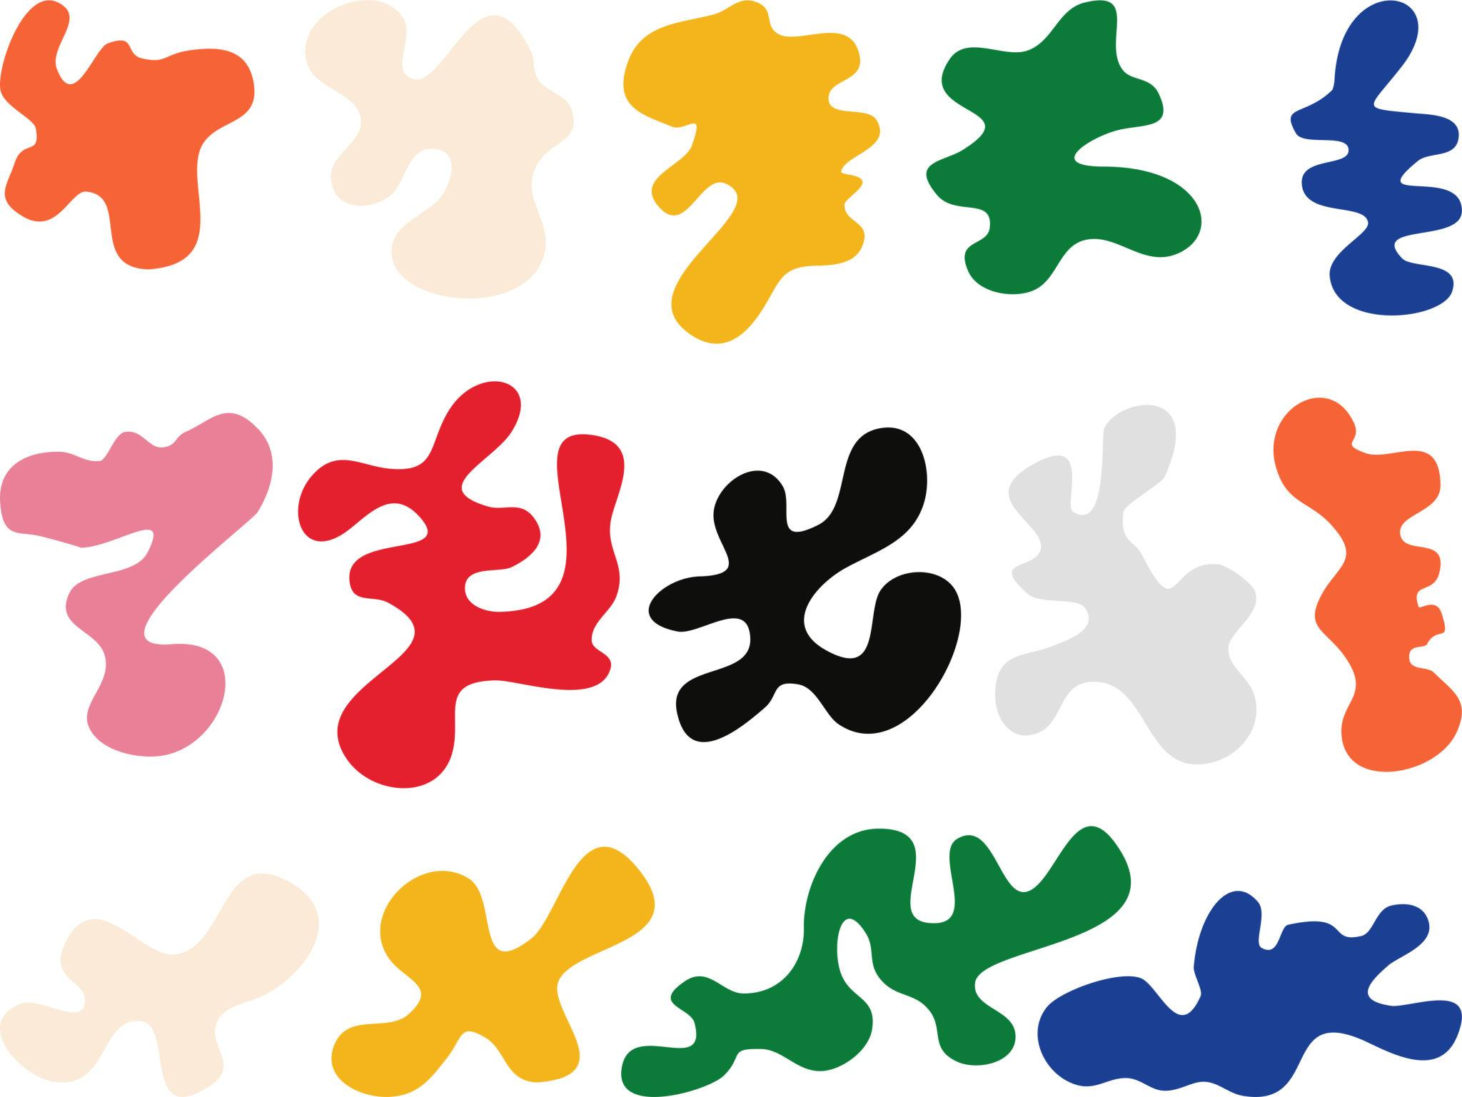
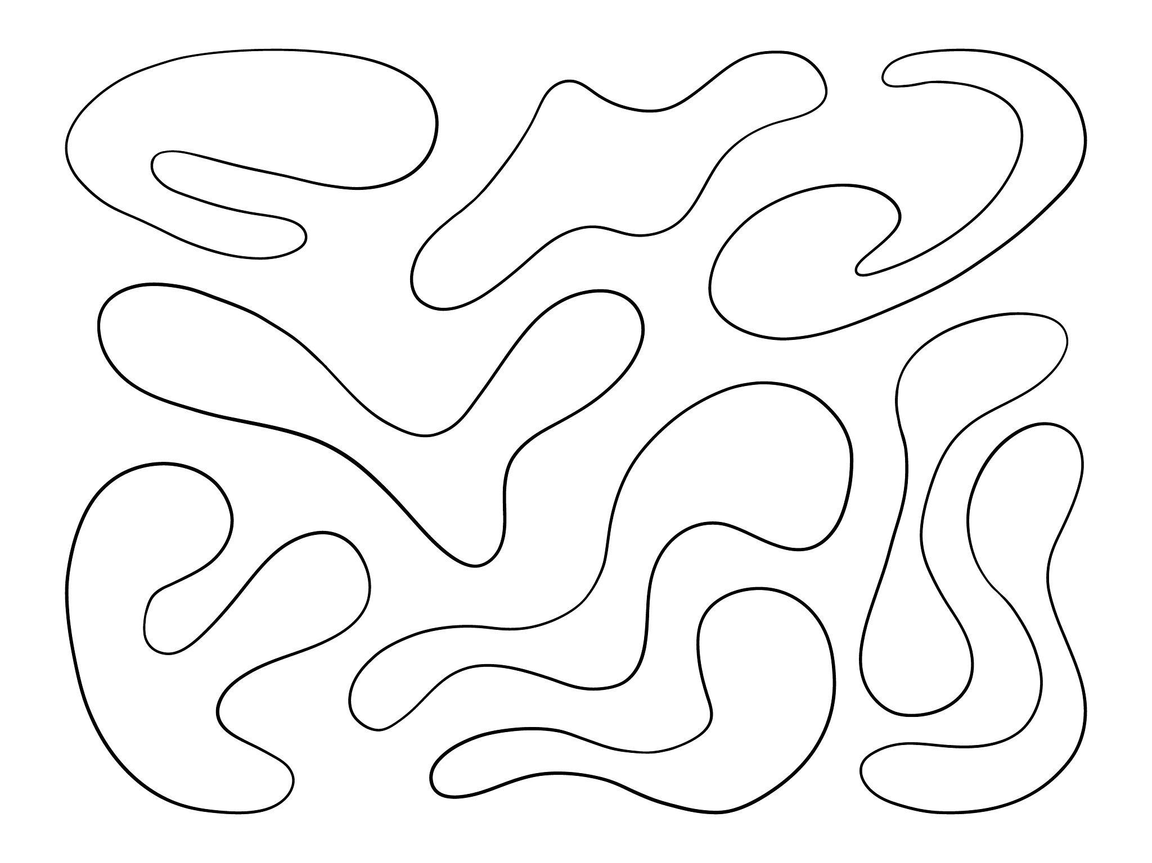
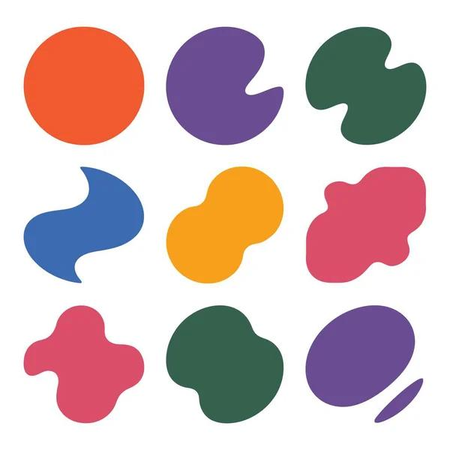
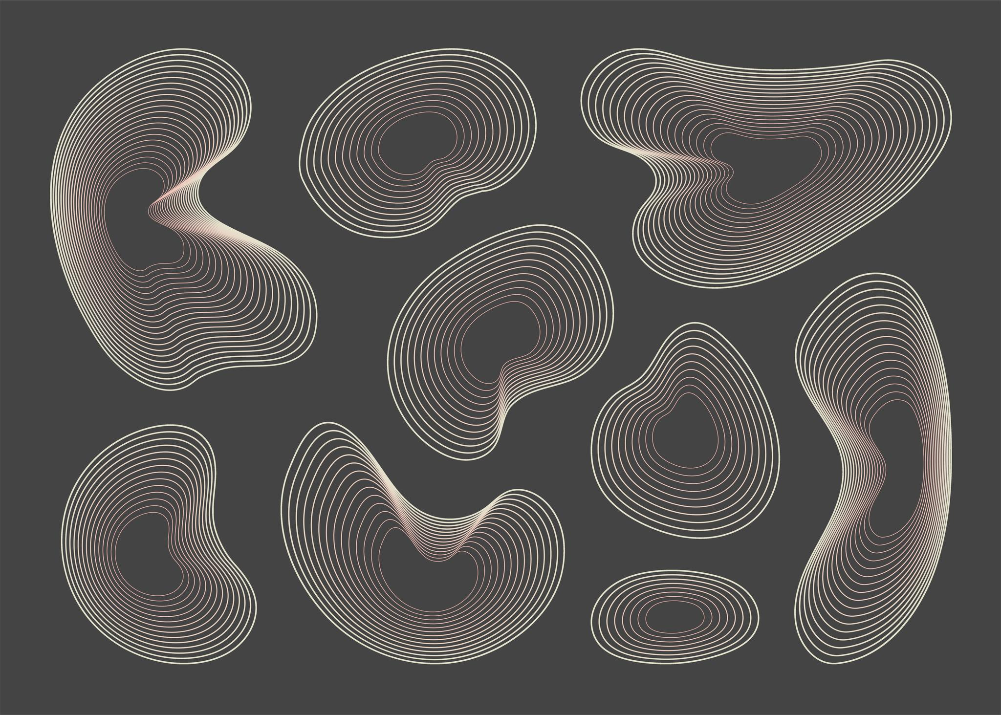
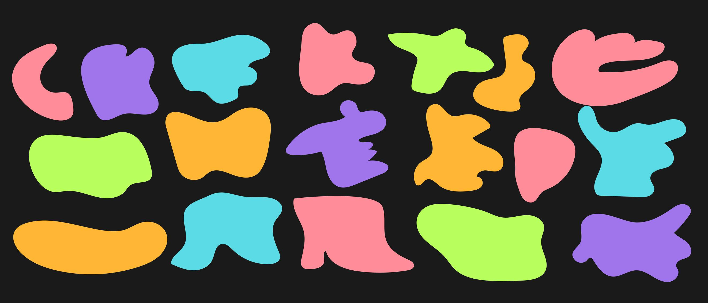
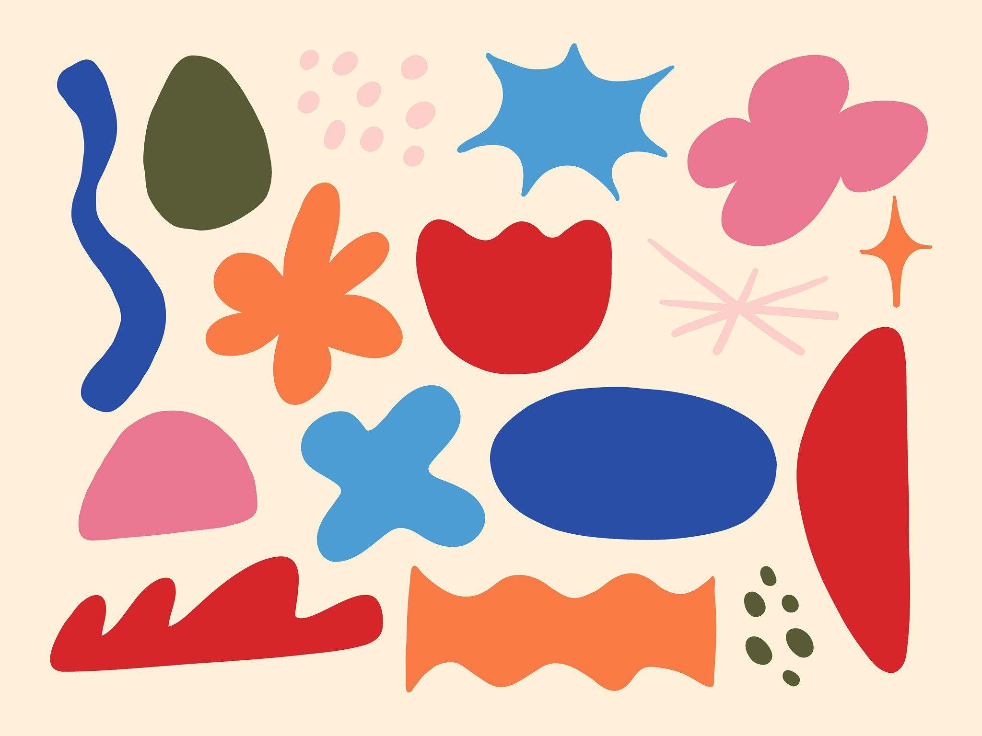

Definition
# Source: AI Source: Provided by: [Data Path: Persons Table -> ID Column: 1, Name_En Column: Motasem Essam] -> From: [ChatGPT] on [7/25/2026]
A Freeform Curved Shape is an irregular curved shape whose boundary does not follow a specific standard geometric form or a fixed predefined pattern.
It is created using curves that can change direction, curvature, and radius freely.
In simple terms:
A freeform curved shape is a non-standard shape made from one or more freely formed curves.

Characteristics
# Source: AI Source: Provided by: [Data Path: Persons Table -> ID Column: 1, Name_En Column: Motasem Essam] -> From: [ChatGPT] on [7/25/2026]
A freeform curved shape typically:
- Has a curved boundary.
- Does not follow a regular geometric shape.
- Does not require equal dimensions.
- Can contain curves with different radii.
- Can change curvature continuously or irregularly.
- Usually has no fixed number of sides or vertices.
- May be asymmetric.
- Can be open or closed depending on its construction.
- Is often defined by a set of control points or curves rather than a simple geometric formula.

Examples

1. Organic Freeform Shape
# Source: AI Source: Provided by: [Data Path: Persons Table -> ID Column: 1, Name_En Column: Motasem Essam] -> From: [ChatGPT] on [7/25/2026]
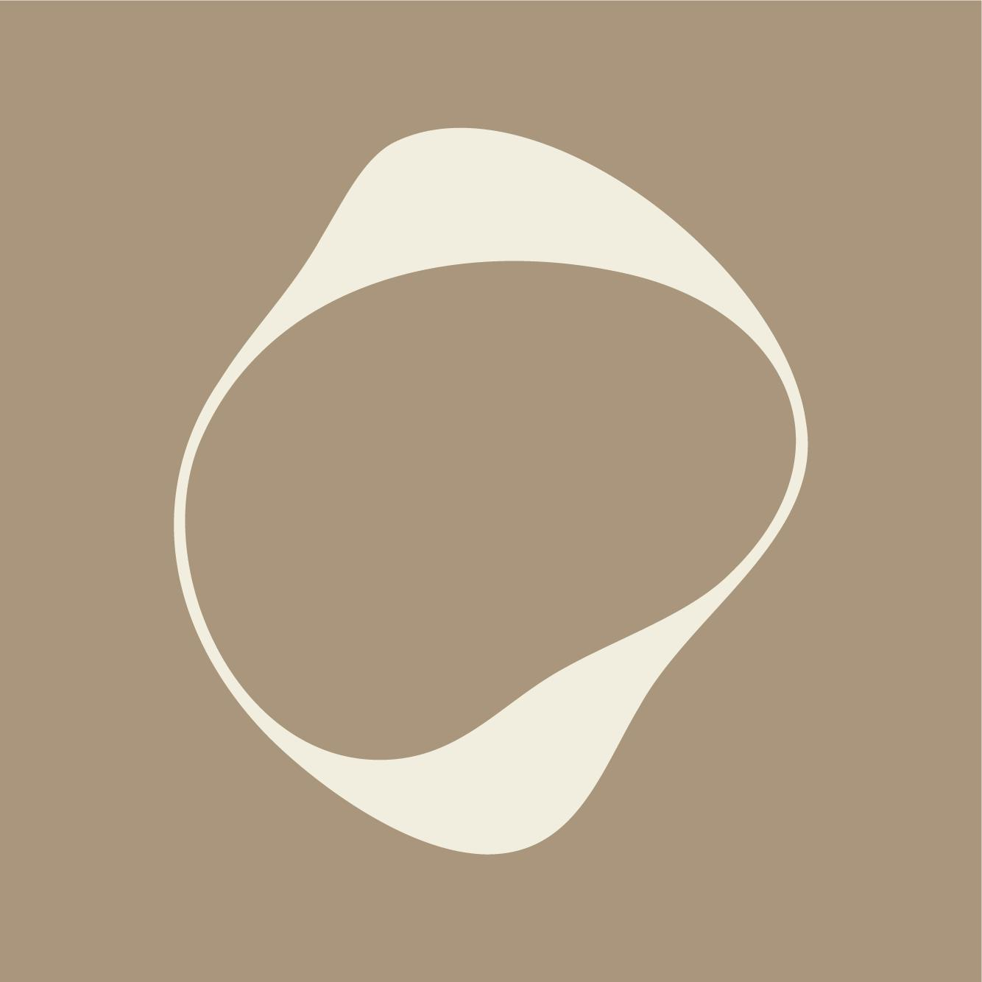
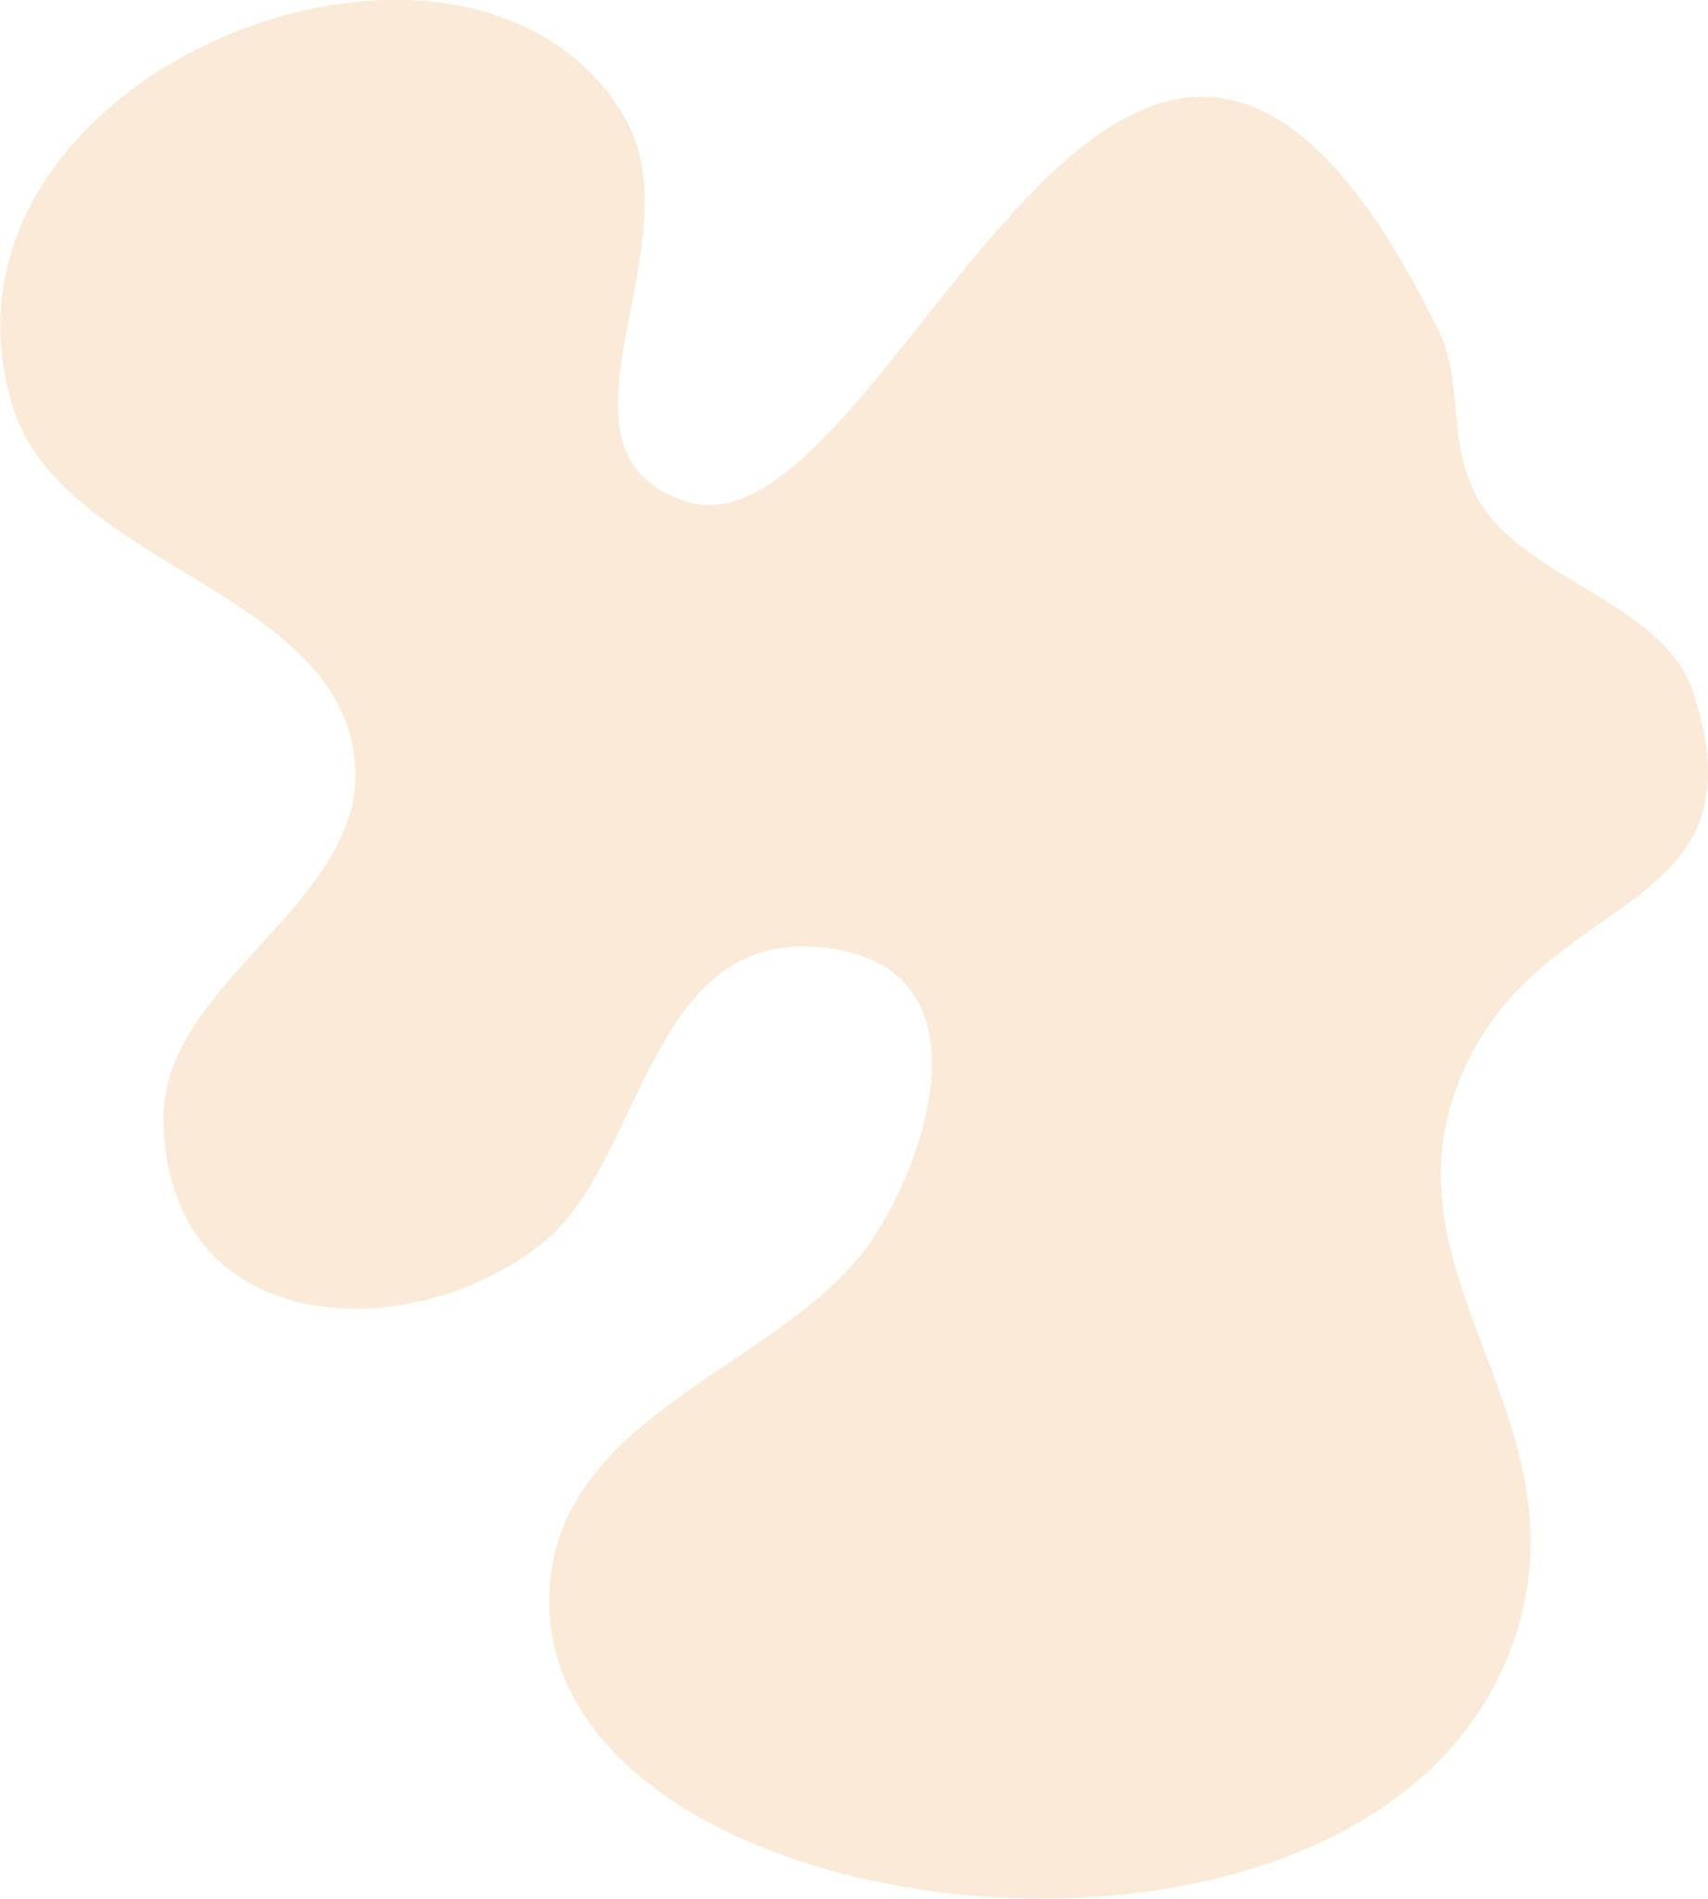
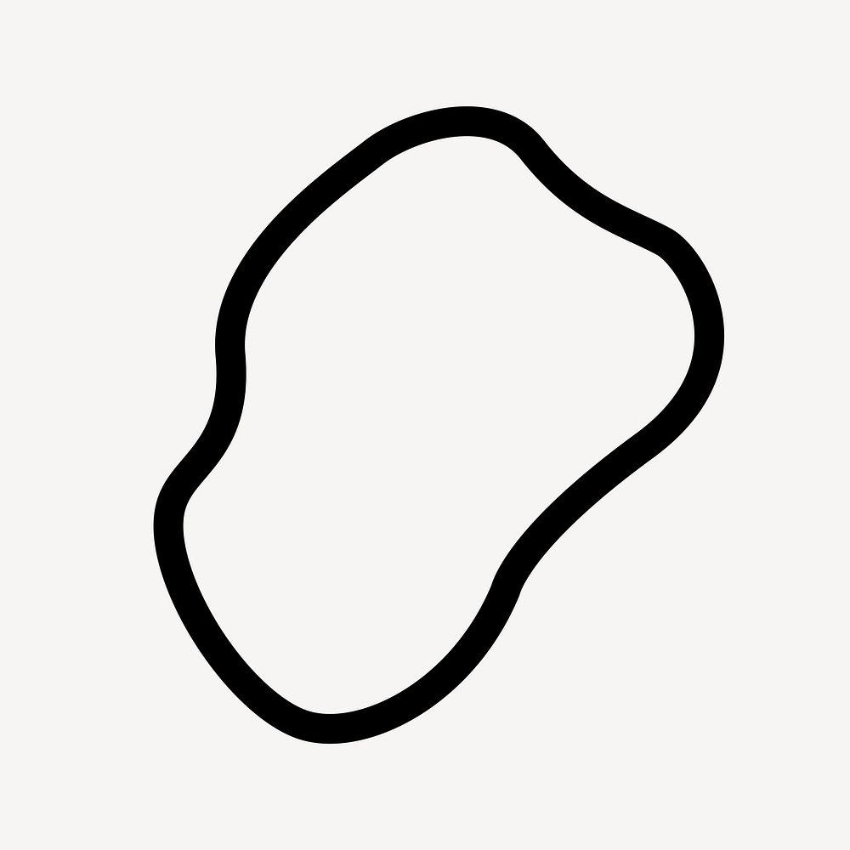
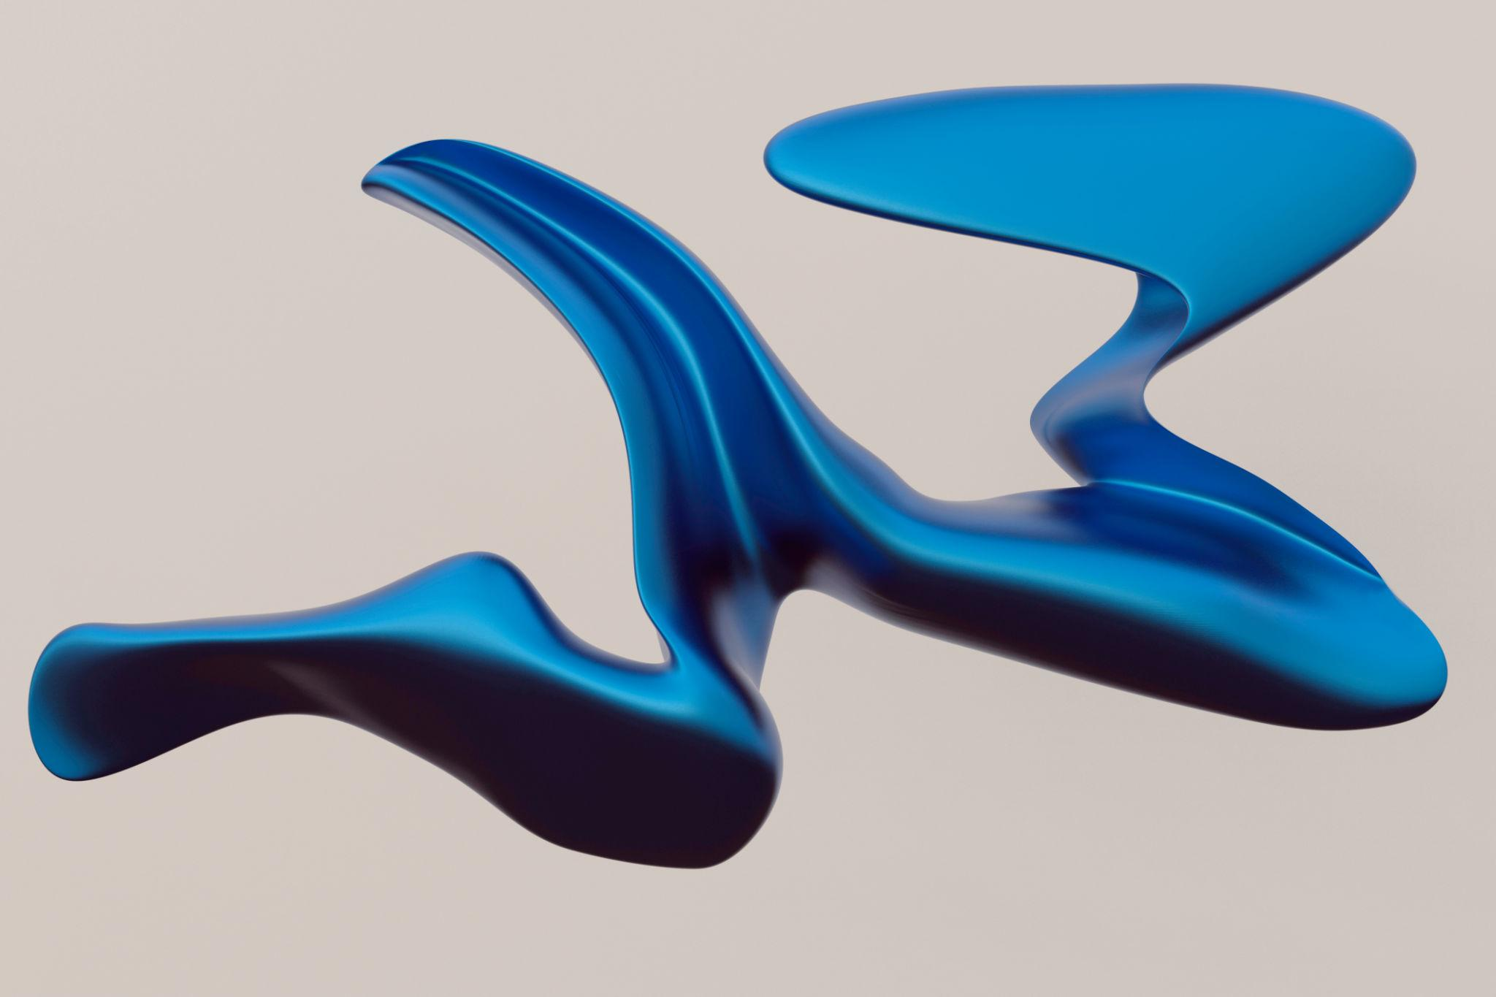
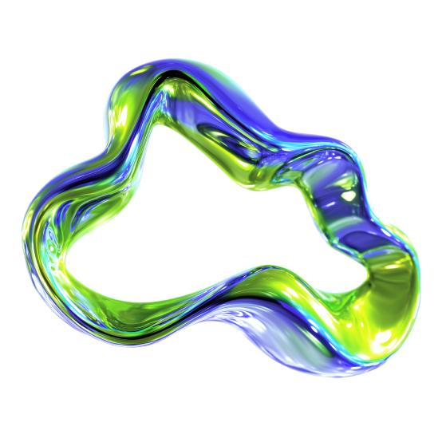
An organic blob-like shape with continuously changing curvature.

2. Wavy Freeform Shape
# Source: AI Source: Provided by: [Data Path: Persons Table -> ID Column: 1, Name_En Column: Motasem Essam] -> From: [ChatGPT] on [7/25/2026]
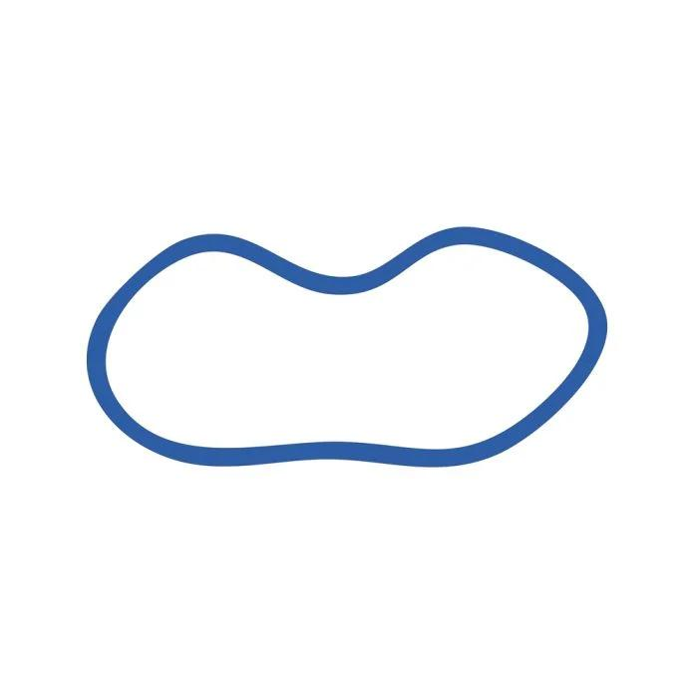
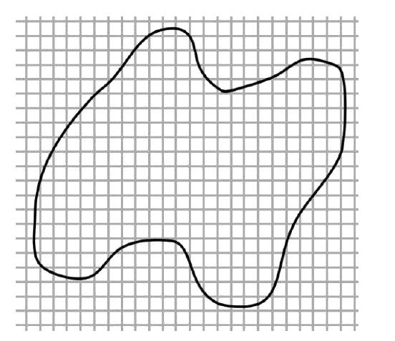
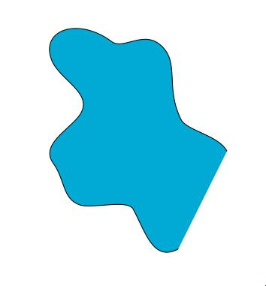
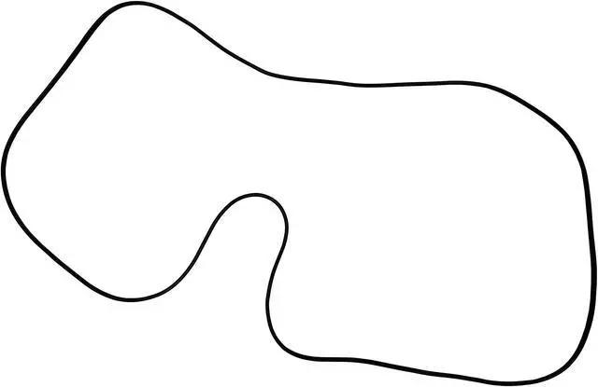
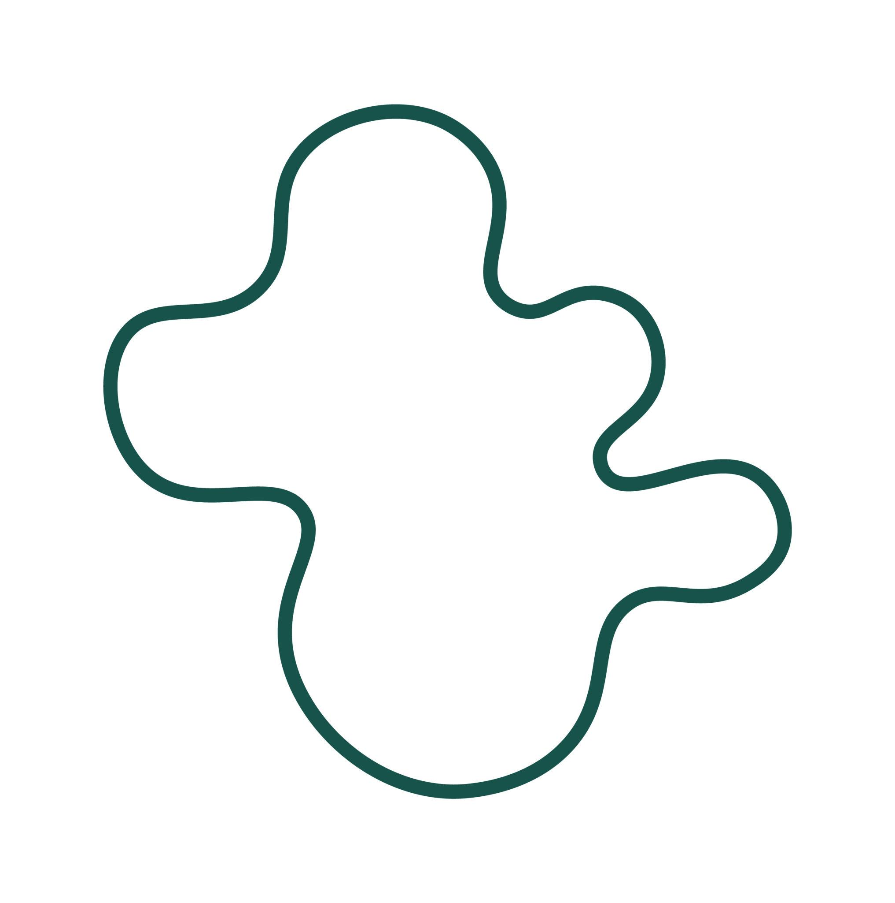
A shape whose boundary repeatedly changes direction and curvature.

3. Asymmetric Freeform Shape
# Source: AI Source: Provided by: [Data Path: Persons Table -> ID Column: 1, Name_En Column: Motasem Essam] -> From: [ChatGPT] on [7/25/2026]
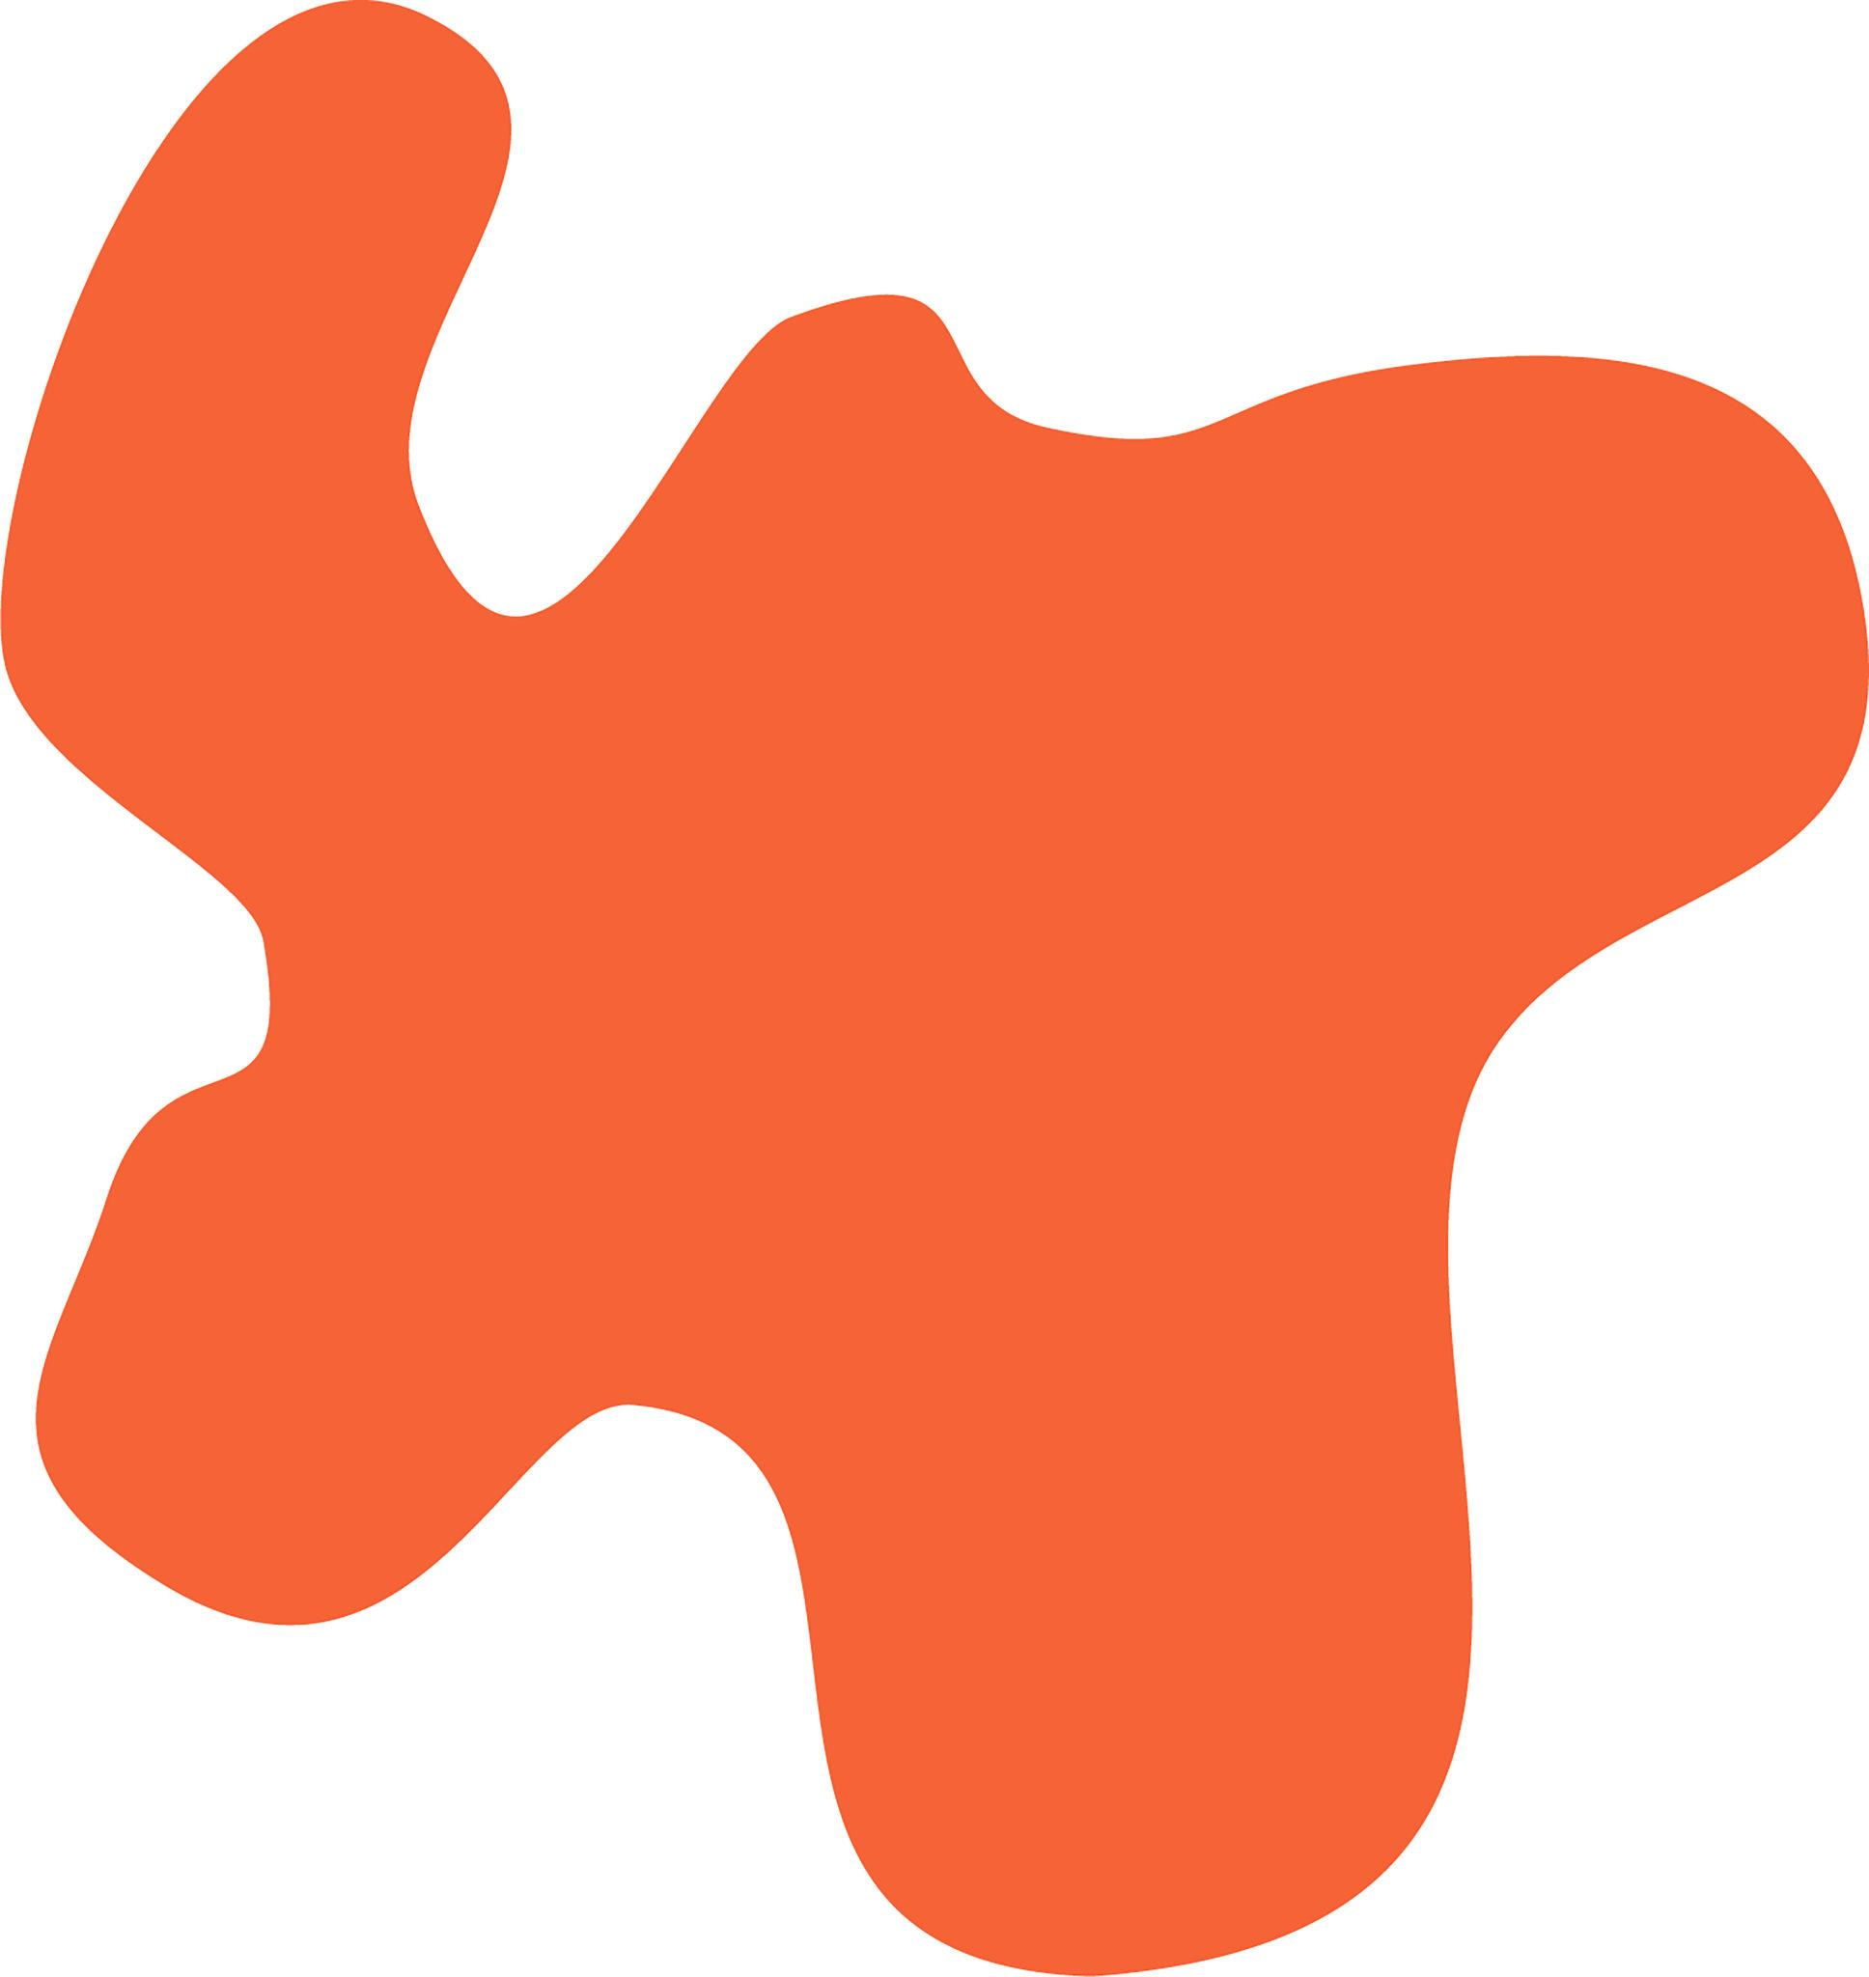
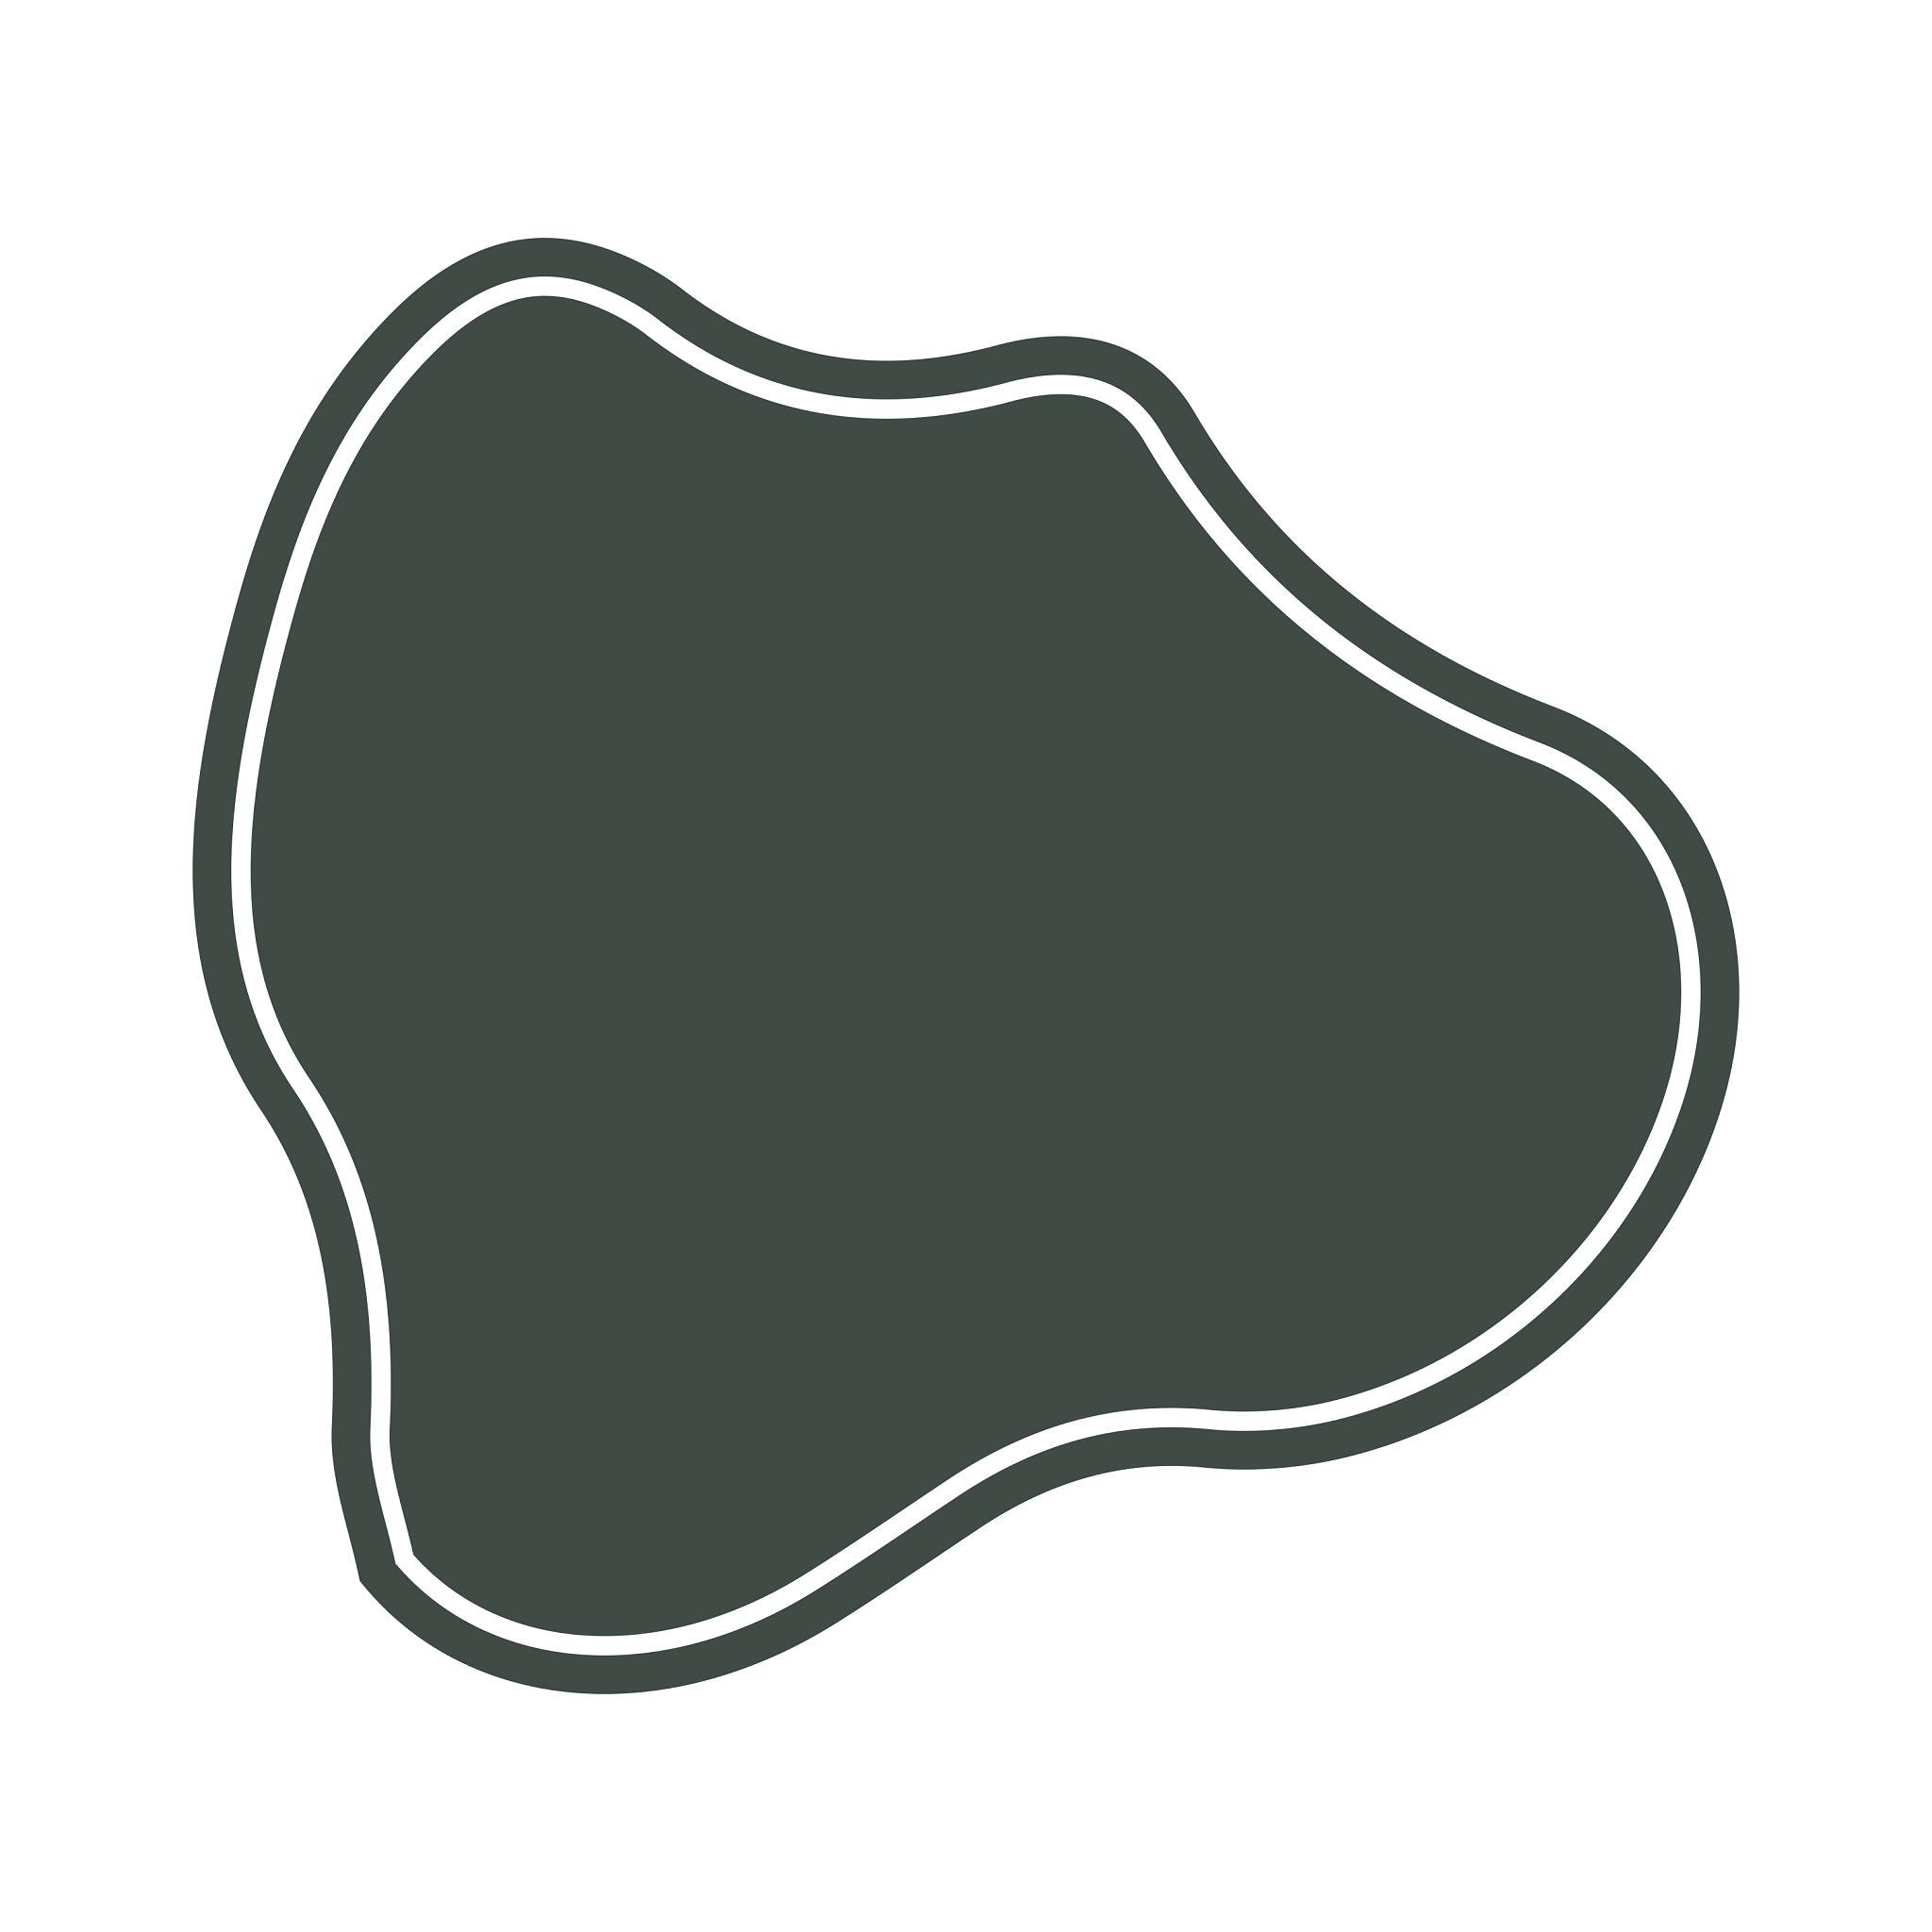
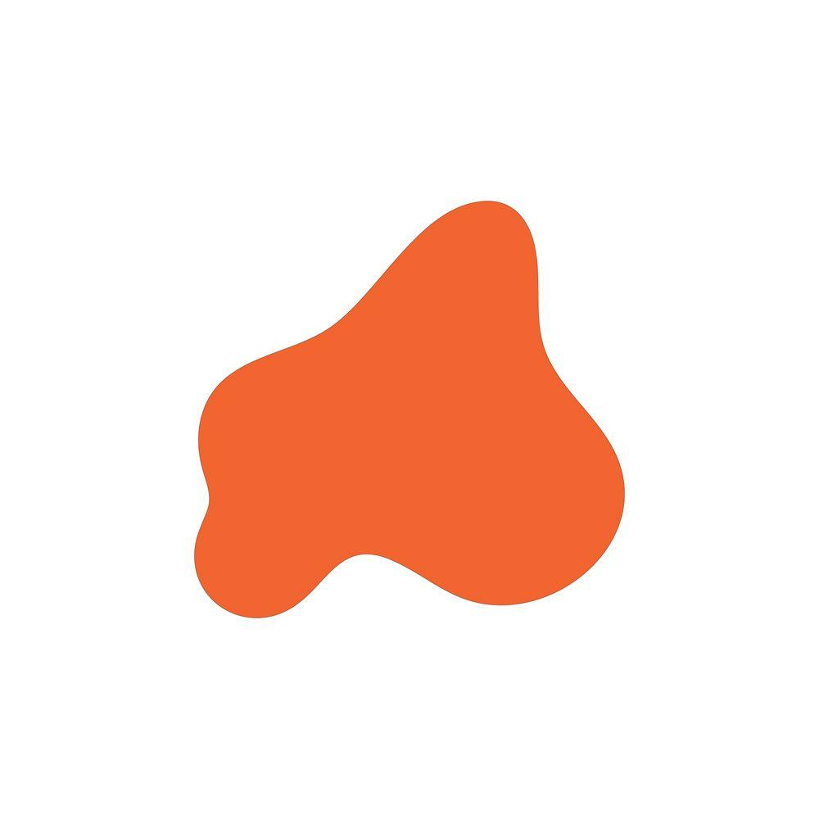
A curved shape without reflectional symmetry.

4. Spline-Based Freeform Shape
# Source: AI Source: Provided by: [Data Path: Persons Table -> ID Column: 1, Name_En Column: Motasem Essam] -> From: [ChatGPT] on [7/25/2026]
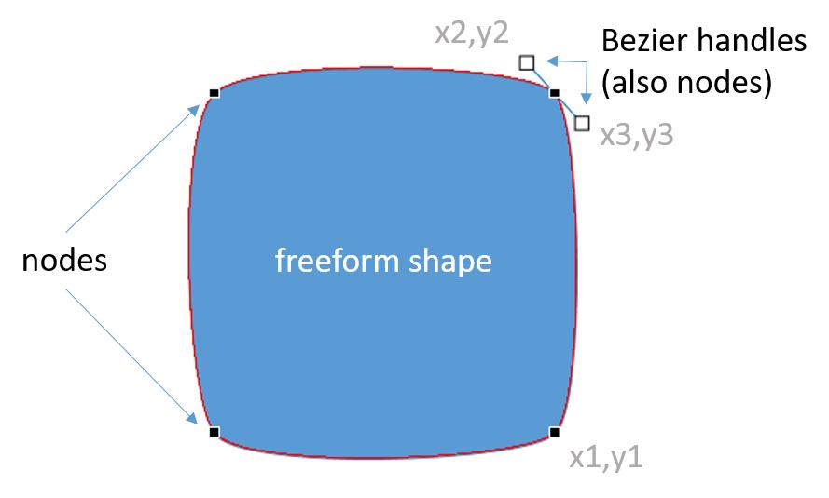
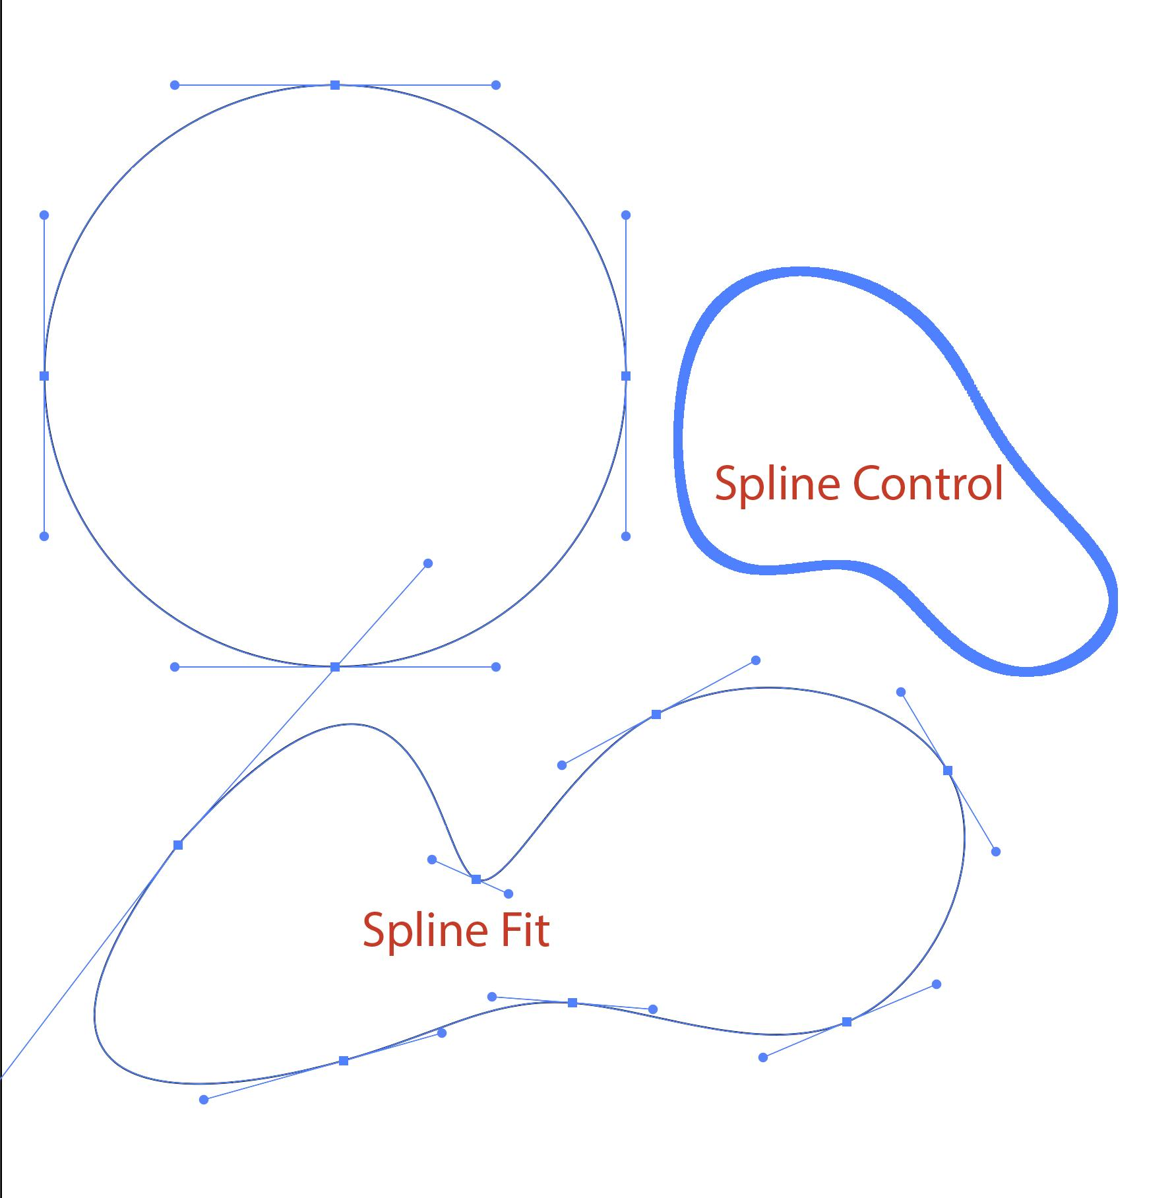
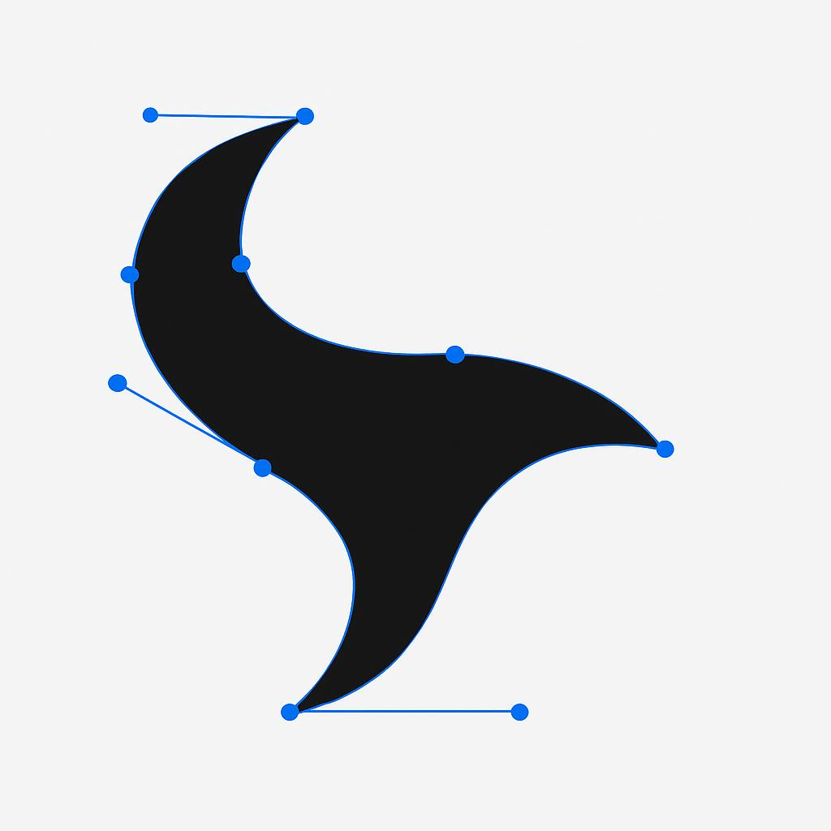
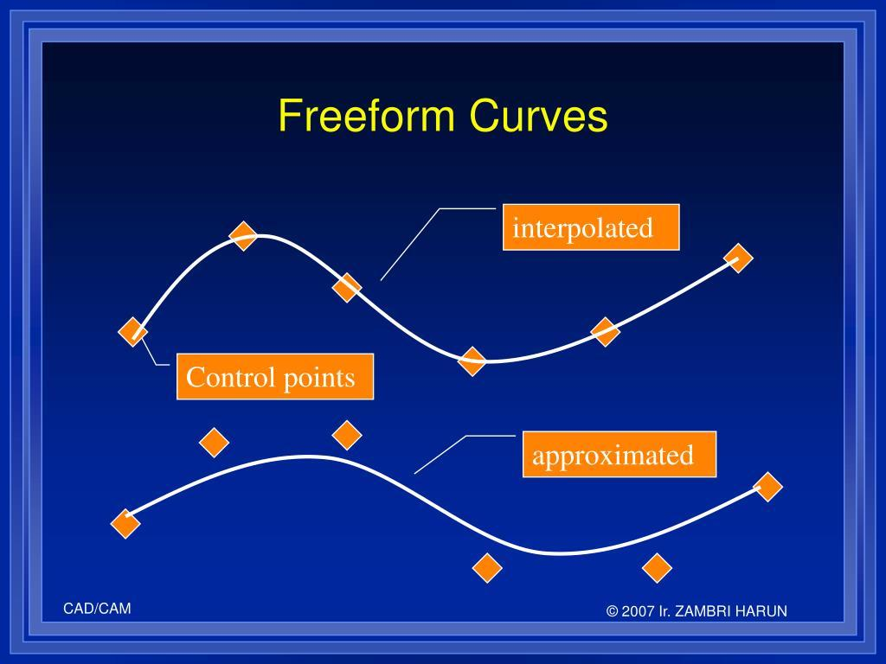
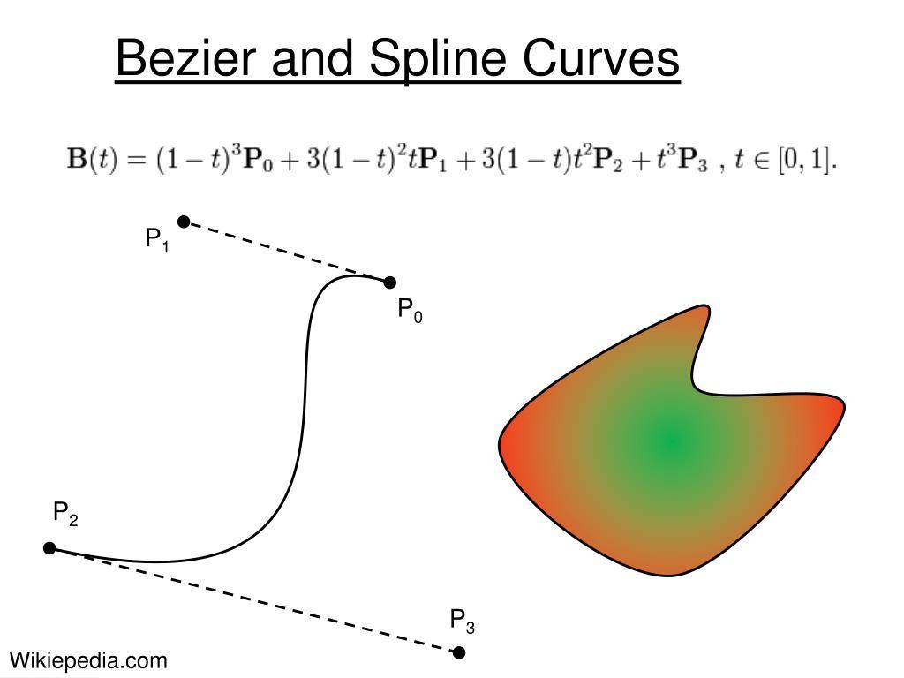
A shape constructed using smooth curves controlled by points or handles.

Mathematical Representation
# Source: AI Source: Provided by: [Data Path: Persons Table -> ID Column: 1, Name_En Column: Motasem Essam] -> From: [ChatGPT] on [7/25/2026]
Unlike circles or ellipses, a freeform curved shape usually does not have one simple standard equation.
It can be represented using parametric curves:
$$x=x\left(t\right), y=y\left(t\right)$$
or using spline curves such as Bézier curves:
$$B\left(t\right)={\left(1-t\right)}^{3}P_{0}+3{\left(1-t\right)}^{2}tP_{1}+3\left(1-t\right)t^{2}P_{2}+t^{3}P_{3}$$
where:
- $P_{0}$ and $P_{3}$ are the endpoints.
- $P_{1}$ and $P_{2}$ are control points.
- $0≤t≤1$.

Freeform vs. Standard Curved Shapes
# Source: AI Source: Provided by: [Data Path: Persons Table -> ID Column: 1, Name_En Column: Motasem Essam] -> From: [ChatGPT] on [7/25/2026]
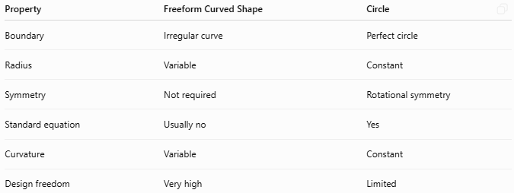
Property | Freeform Curved Shape | Circle
Boundary | Irregular curve | Perfect circle
Radius | Variable | Constant
Symmetry | Not required | Rotational symmetry
Standard equation | Usually no | Yes
Curvature | Variable | Constant
Design freedom | Very high | Limited

Freeform vs. Natural Irregular Curved Shapes
# Source: AI Source: Provided by: [Data Path: Persons Table -> ID Column: 1, Name_En Column: Motasem Essam] -> From: [ChatGPT] on [7/25/2026]
These two categories can overlap, but they describe different ideas.
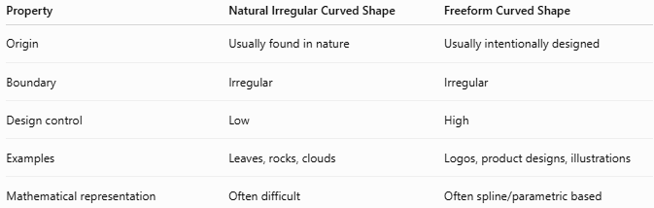
Property | Natural Irregular Curved Shape | Freeform Curved Shape
Origin | Usually found in nature | Usually intentionally designed
Boundary | Irregular | Irregular
Design control | Low | High
Examples | Leaves, rocks, clouds | Logos, product designs, illustrations
Mathematical representation | Often difficult | Often spline/parametric based
A leaf can therefore be both a natural irregular curved shape and a freeform-like shape, depending on the classification system being used.

Closed Freeform Curved Shape
# Source: AI Source: Provided by: [Data Path: Persons Table -> ID Column: 1, Name_En Column: Motasem Essam] -> From: [ChatGPT] on [7/25/2026]
A freeform curve can form a closed region:
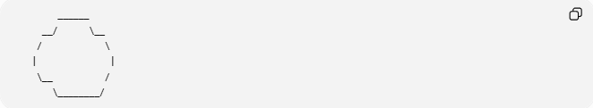
______
__/ \__
/ \
| |
\__ /
\________/
The curve returns to its starting point, creating a bounded region.

Open Freeform Curved Shape
# Source: AI Source: Provided by: [Data Path: Persons Table -> ID Column: 1, Name_En Column: Motasem Essam] -> From: [ChatGPT] on [7/25/2026]
A freeform curve does not necessarily have to form a closed region:
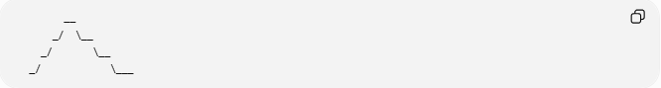
__
_/ \__
_/ \__
_/ \___
Its endpoints remain separate.

Area
# Source: AI Source: Provided by: [Data Path: Persons Table -> ID Column: 1, Name_En Column: Motasem Essam] -> From: [ChatGPT] on [7/25/2026]
For a closed freeform curved shape, the enclosed area can be determined or approximated using numerical methods.
For a simple function:
$$A=\int_{a}^{b}{f}\left(x\right),dx$$
For a parametric closed curve, area can be calculated using:
$$A=\frac{12}{\oint{\left(x,dy-y,dx\right)}}$$
For digitally created shapes, the area can also be obtained from computational geometry or pixel-based measurement.

Perimeter
# Source: AI Source: Provided by: [Data Path: Persons Table -> ID Column: 1, Name_En Column: Motasem Essam] -> From: [ChatGPT] on [7/25/2026]
The perimeter of a freeform closed curve is its total curve length.
For a parametric curve:
$$x=x\left(t\right), y=y\left(t\right)$$
the arc length is:
$$\boxed{L=\int_{a}^{b}{\sqrt{{\left(\frac{dx}{dt}\right)}^{2}+{\left(\frac{dy}{dt}\right)}^{2}}},dt}$$

Applications
# Source: AI Source: Provided by: [Data Path: Persons Table -> ID Column: 1, Name_En Column: Motasem Essam] -> From: [ChatGPT] on [7/25/2026]
Freeform curved shapes are widely used in:
- Computer Graphics
- CAD
- Industrial Design
- Product Design
- Architecture
- Logo Design
- Typography
- Animation
- UI/UX Design
- Automotive Design
- 3D Modeling

Examples in Design
# Source: AI Source: Provided by: [Data Path: Persons Table -> ID Column: 1, Name_En Column: Motasem Essam] -> From: [ChatGPT] on [7/25/2026]
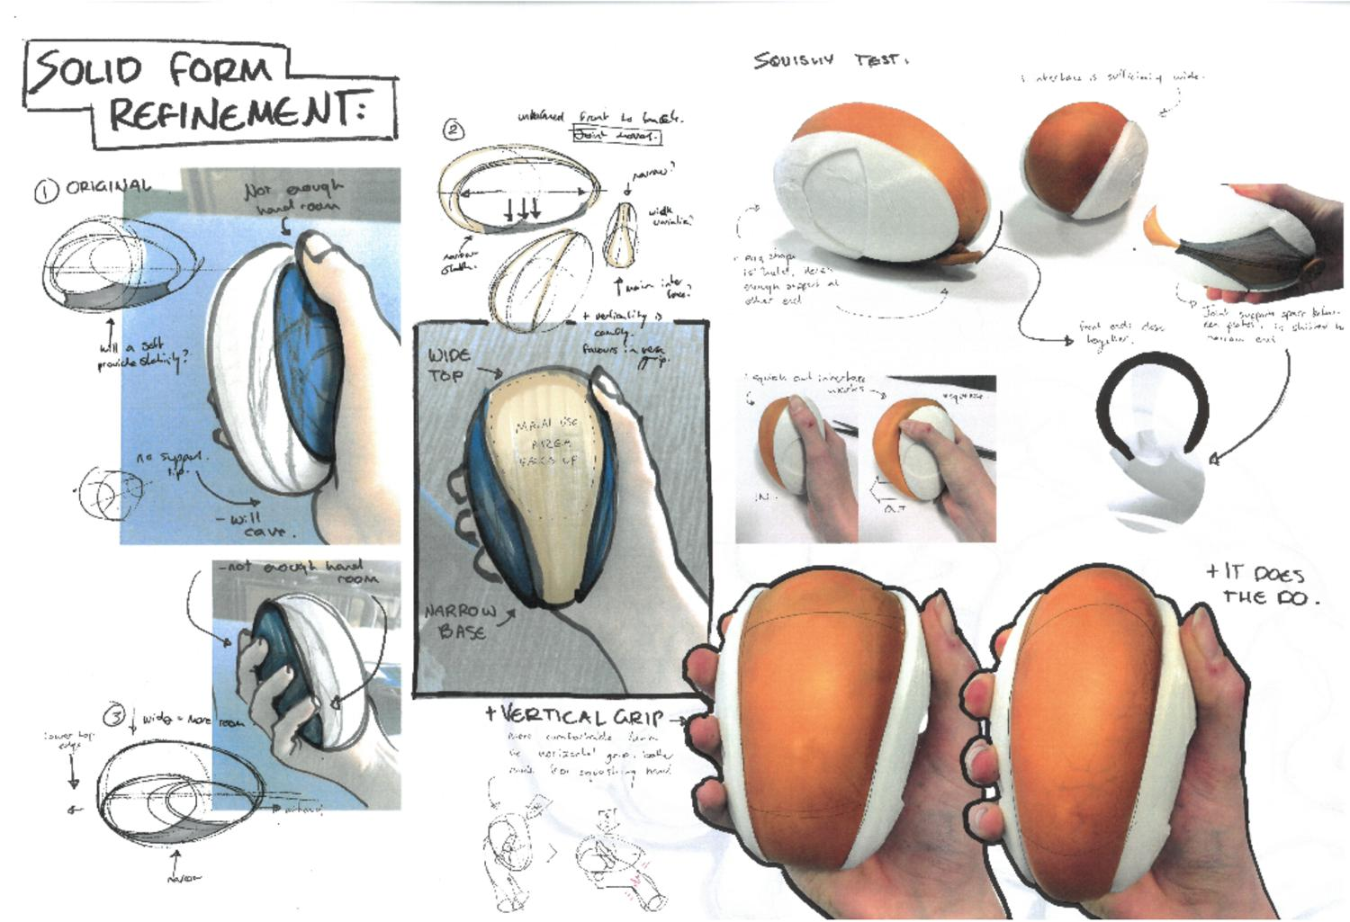
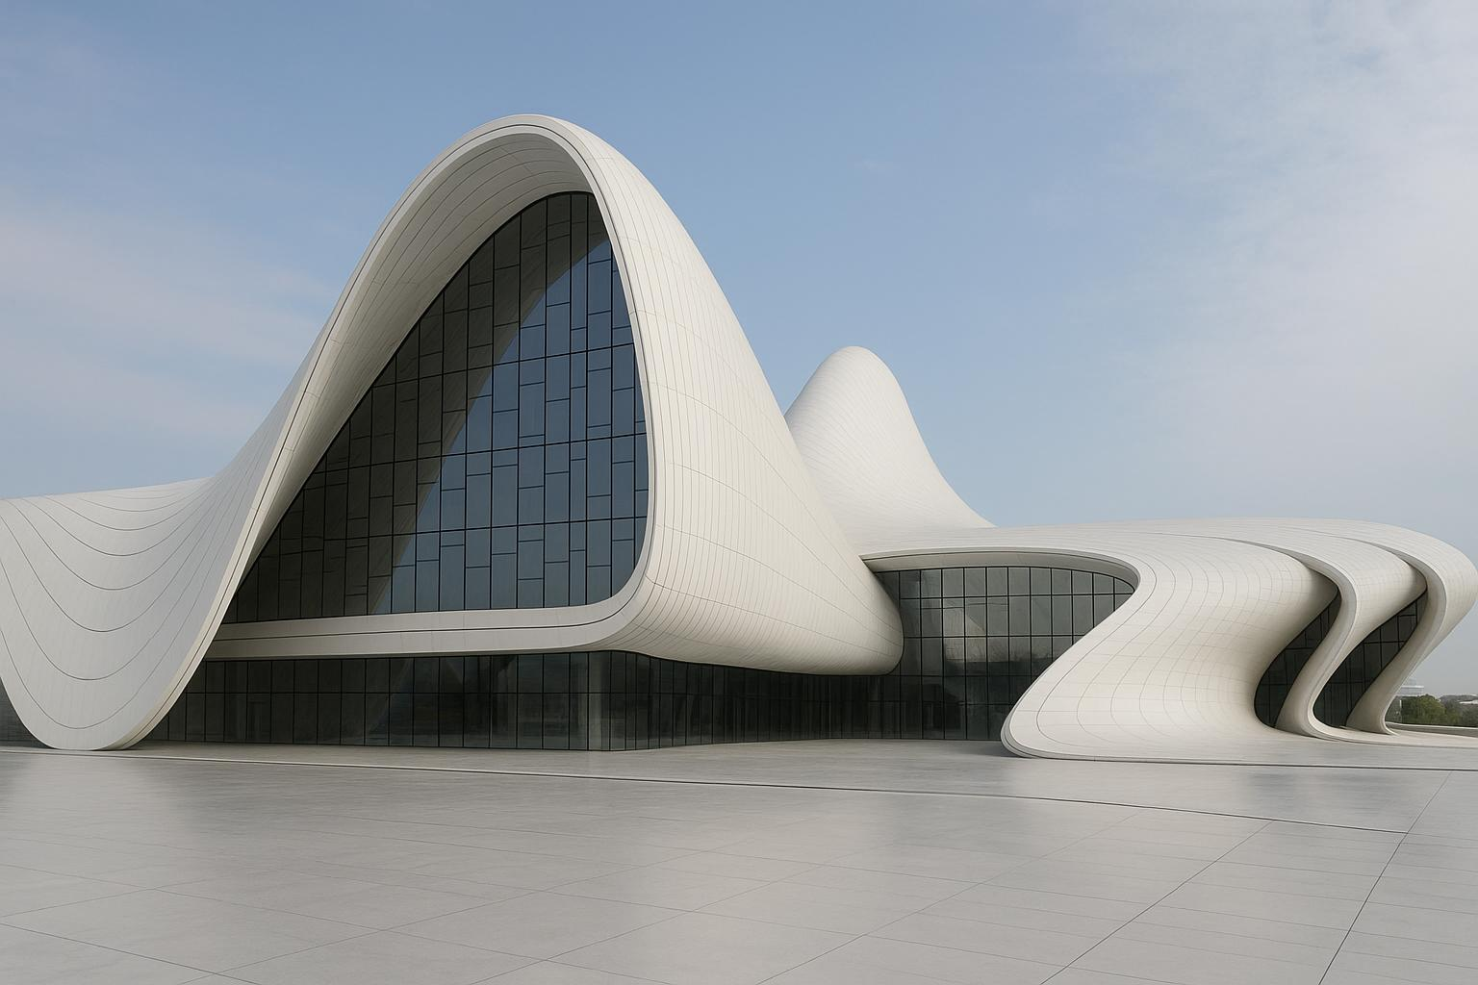
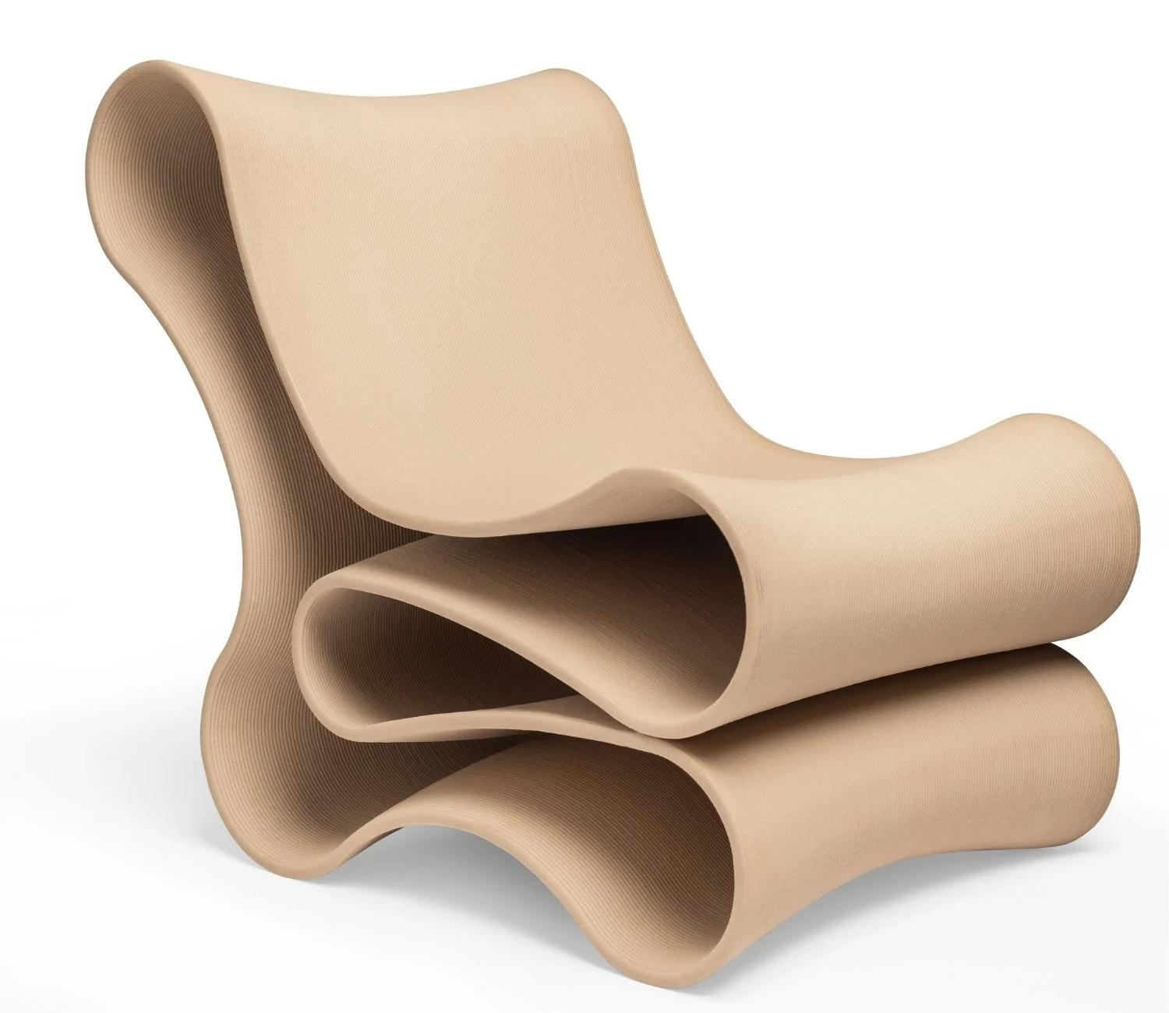
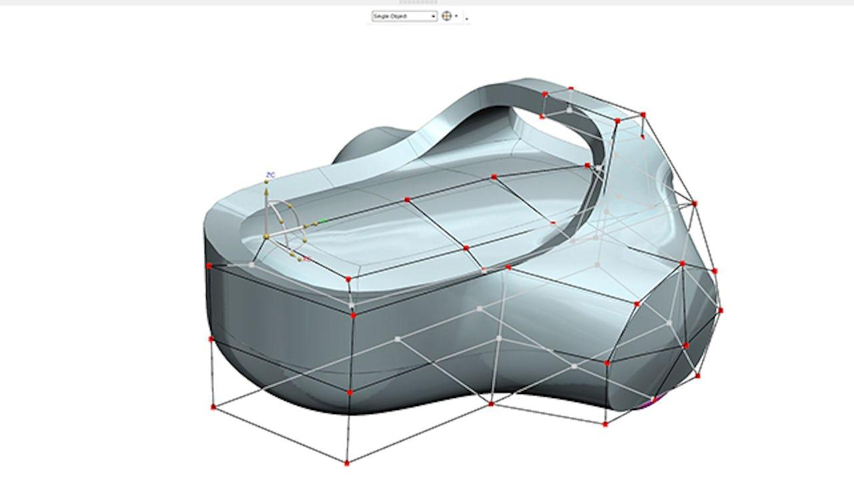
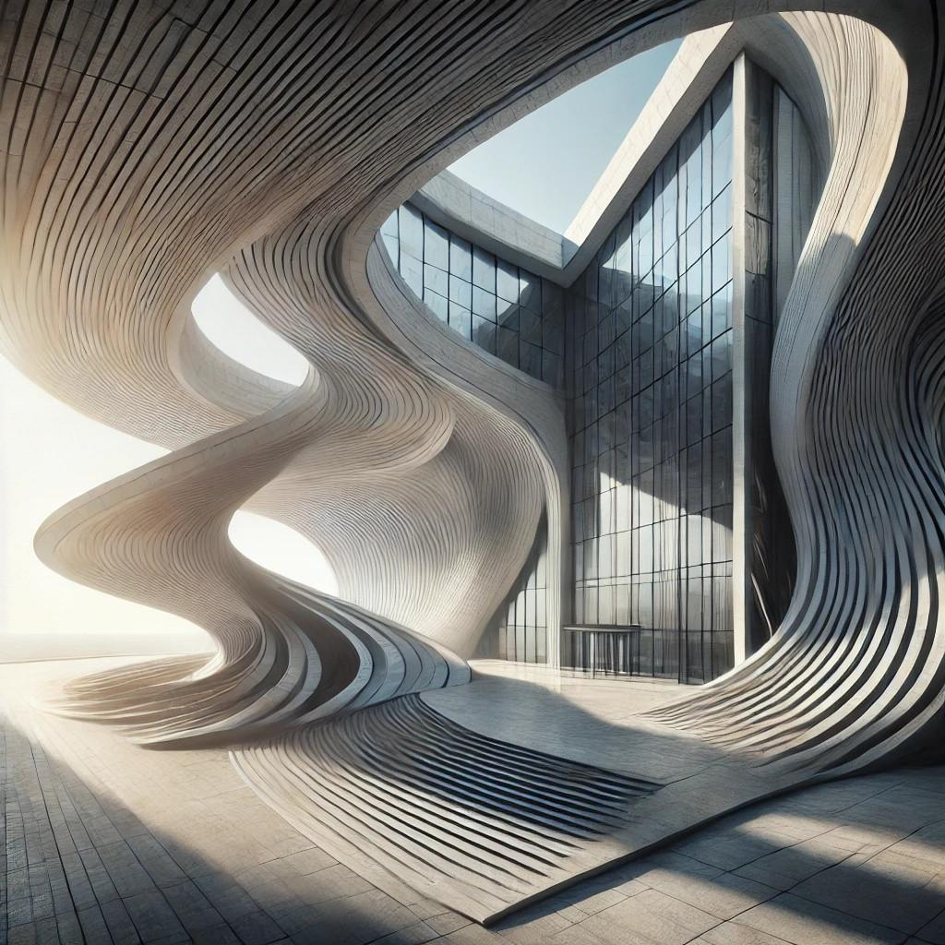
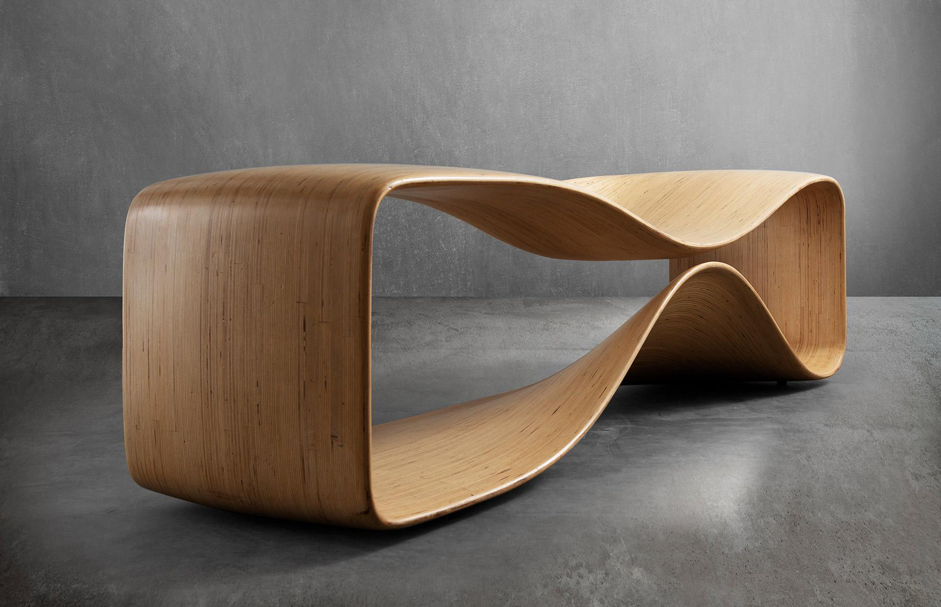
Examples include:
- Product bodies.
- Car body panels.
- Furniture outlines.
- Architectural forms.
- Logos.
- Decorative patterns.
- Digital illustrations.

Classification
# Source: AI Source: Provided by: [Data Path: Persons Table -> ID Column: 1, Name_En Column: Motasem Essam] -> From: [ChatGPT] on [7/25/2026]
A useful hierarchy for your geometry project is:
Irregular Curved Shapes
- Natural Irregular Curved Shapes
- Freeform Curved Shapes
- Mathematically Defined Irregular Curved Shapes
Under Freeform Curved Shapes, you can further classify:
- Organic Freeform Shapes
- Wavy Freeform Shapes
- Asymmetric Freeform Shapes
- Spline-Based Freeform Shapes
- Open Freeform Curves
- Closed Freeform Shapes

Key Points
# Source: AI Source: Provided by: [Data Path: Persons Table -> ID Column: 1, Name_En Column: Motasem Essam] -> From: [ChatGPT] on [7/25/2026]
$$\boxed{\text{Freeform Curved }\text{ShapeIrregular}\text{ Curve}+\text{No Fixed Standard Geometric Form}}$$
The most important distinction is that freeform describes the freedom of the shape's construction, while irregular describes the lack of a uniform geometric pattern.
Examples
Freeform curved shapes: blobs, artistic curves, product outlines, logos, spline-based designs.
Natural irregular curved shapes: leaves, rocks, clouds, shells, coastlines.
Regular curved shape: circle.

Conclusion
# Source: AI Source: Provided by: [Data Path: Persons Table -> ID Column: 1, Name_En Column: Motasem Essam] -> From: [ChatGPT] on [7/25/2026]
Freeform Curved Shapes are irregular curved forms that do not follow a fixed standard geometric pattern such as a circle or ellipse. Their boundaries can change direction and curvature freely, allowing a high degree of flexibility in design and construction. They may be open or closed, symmetric or asymmetric, and can be represented using parametric curves, Bézier curves, or spline-based methods. Freeform curved shapes are widely used in geometry, computer graphics, CAD, architecture, engineering, product design, and digital illustration.

